**Login Process:**

**Make My Labs Login:**

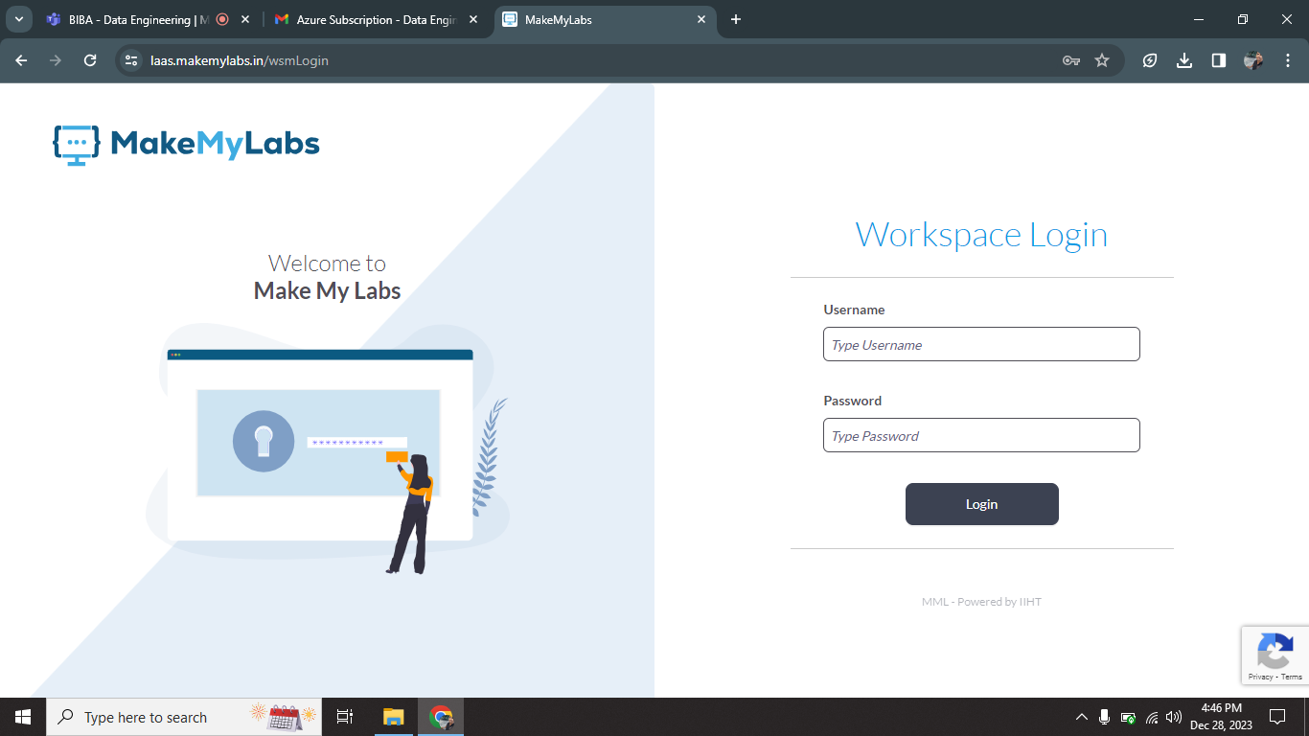

I was successfully login into MakeMyLabs portal using login credential that are shared in my mail.

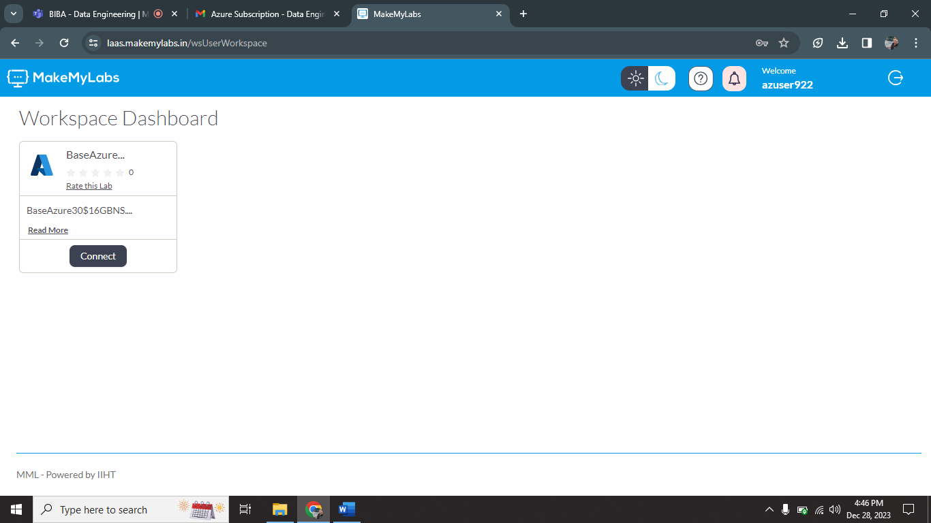

After login into this portal I click Connect option.

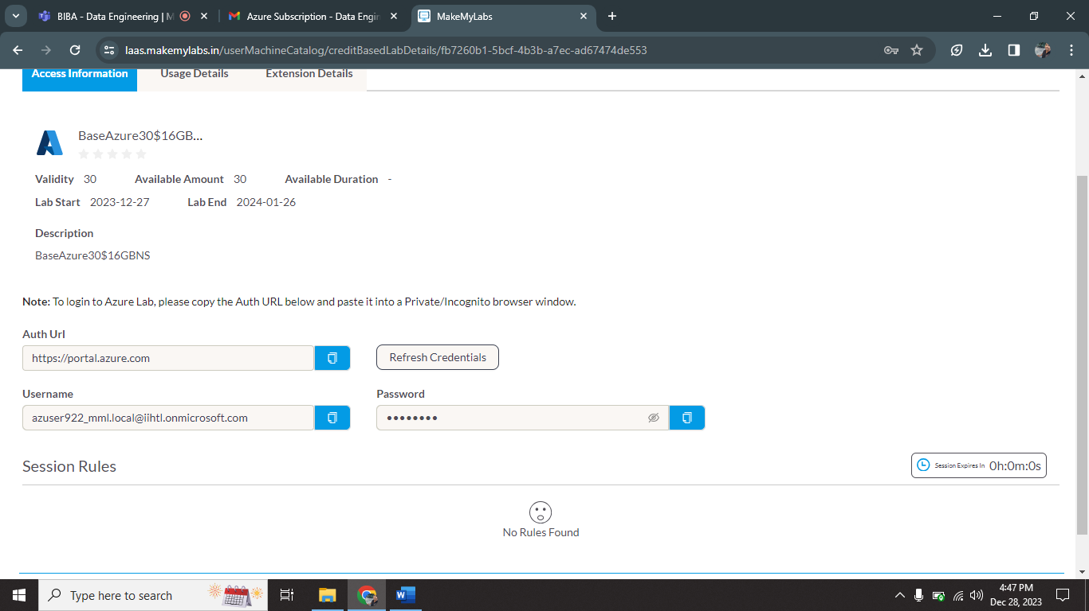

It gives temporary username and password for Azure portal login.

**Azure Account Login:**

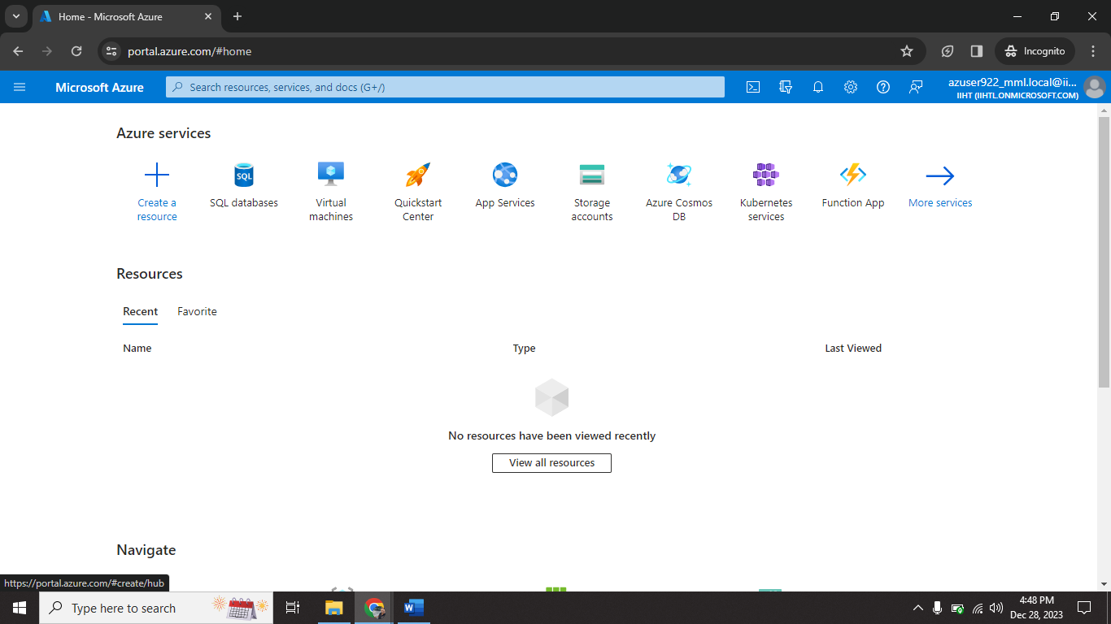

I have successfully login into Azure account using username, password that are shown in MakeMyLabs portal.

**Azure Databricks:**

It is a combination of Apache spark and databricks services that are hosted by azure platform.

**Apache spark:**

Apache Spark is a lightning-fast unified analytics engine for big data processing and machine learning.

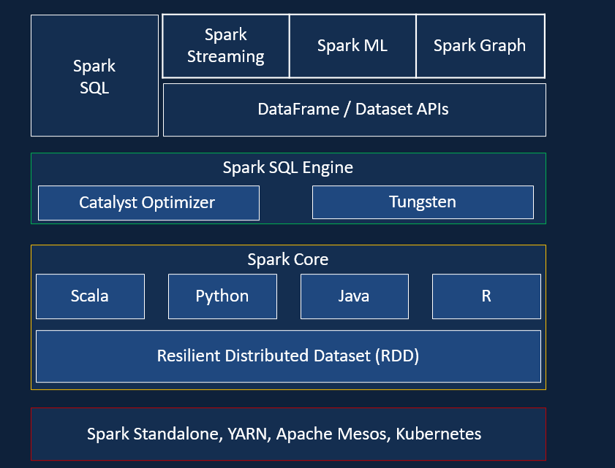

**Databricks:**

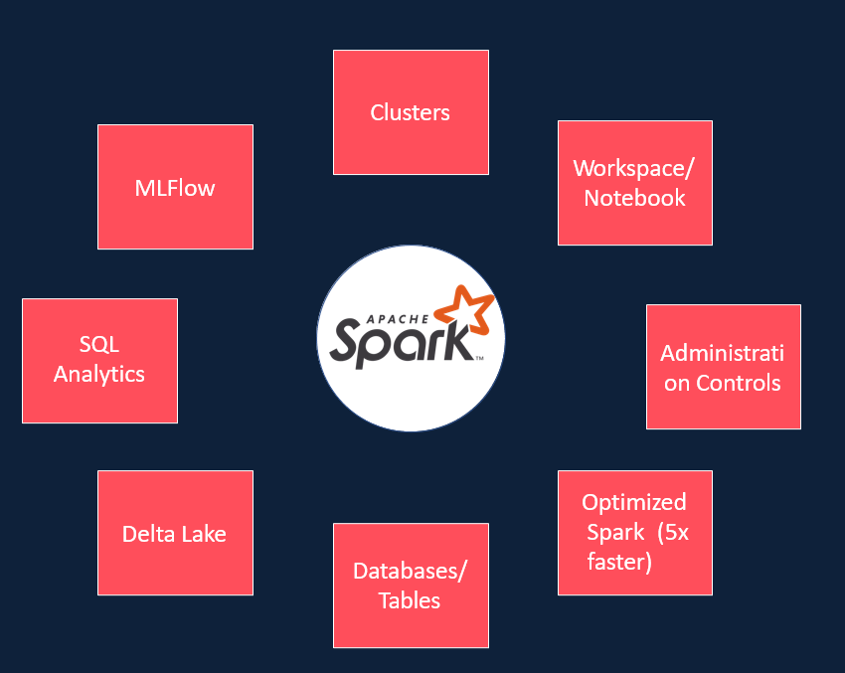 It is a collection of more services combined by apache spark.

**Azure databricks:**

It provides databricks services through the cloud platform.

